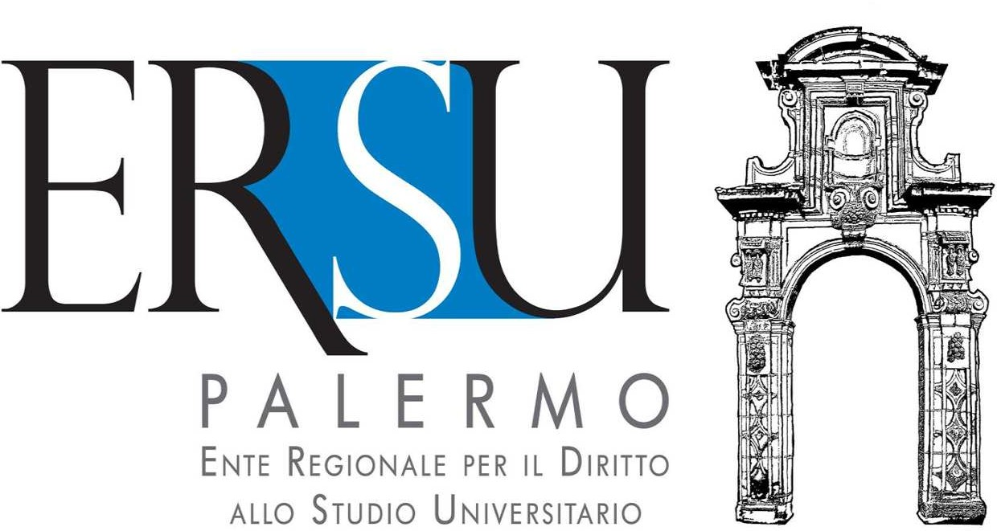
Mod. 07/ERSUPA_Decertificazioni

Substitute Declaration of Self - Certification
Renouncement of benefits for the right to study at University of ERSU of Palermo

The undersigned

born on __/__/____in___ County

tax payer identification number , participant in the competition announcement for the allocation of scholarships and services for the right to university study of the ERSU of Palermo for the academic year ___________(practice n____________).

aware that anyone who makes false declarations is punished under the Penal Code and special laws on the matter, pursuant to and for the purposes of the D.P.R. n. 445/2000

DECLARE

- to revoke the aforementioned request and to renounce the benefits for the right to university study for the academic year _______;

- Other declarations

Attachments:

  - copy of identification document;

Place and Date Signature

